***Invited Meeting Scheduler***

***User Manual***

**Version: 0.5**

**By: Compacted Design**

Leo Bian - Project Manager

Srashta Maharjan - Systems Analyst

Jeffrey Jiang - Lead Programmer

**Terminology** **2**

**Start Menu** **2**

**Data Entry** **3**

Manual Data Entry 4

Spreadsheet Data Entry 5

**Rotation Information** **7**

**Schedule Manager** **8**

**Information Sheet** **11**

**Map** **12**

# Terminology

# Start Menu

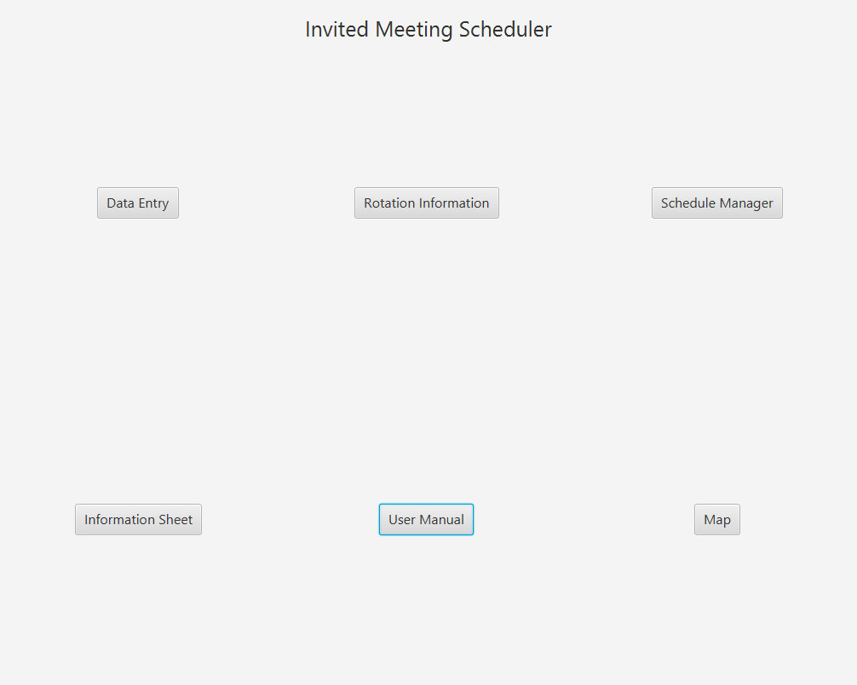

There are 6 buttons on the Start Menu. Clicking on each one does something different.

**Data Entry** - Leads to the Data Entry window for inputting data into the application

**Rotation Information** - Leads to the Rotation Information window where you can change the text associated with each rotation location.

**Schedule Manager** - Leads to the Schedule Manager window where you can create the rotation groups and the actual schedules.

**Information Sheet** - Leads to the Information Sheet window where you can edit the links and captions that appear on the information sheet.

**Guide** - Opens the User Manual in Word.

**Map** - Leads to the Map window where you can edit the map that appears on the schedule sheet.

# Data Entry

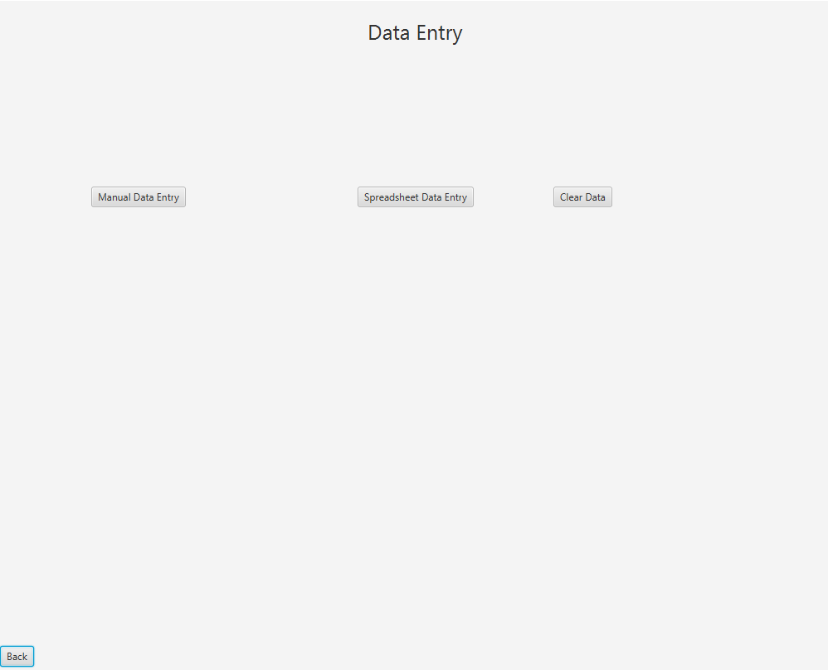

There are 4 buttons on this window

**Back** - Leads back to the Start Menu

**Manual Data Entry** - Opens the manual data entry box in the window.

**Spreadsheet Data Entry** - Opens the spreadsheet data entry box in the window

**Clear Data** - Opens up a Popup Window with a **yes button** and a **no button**. Clicking on the **yes button** deletes all stored student information in the application, as well as closing the Popup Window. Clicking on the **no button** just closes the Popup Window

## Manual Data Entry

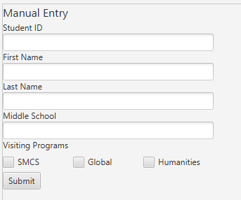

The Manual Data Entry box is for manually entering data into the application as opposed to inputting the information of the student participants through a spreadsheet.

This window has 4 text fields, 3 checkboxes, and a button.

The text fields all request a different value.

The first text field (Student ID) needs a 6 digit integer, which is equal to the Student ID of the

The next 3 text fields (First Name, Last Name, Middle School) need the words representative of the First Name, Last Name, and Middle School of the Student.

The 3 checkboxes are used to denote the houses the student wishes to visit.

Clicking the Submit Button will take the information from each field and checkbox and enter the information into the database of the application, assuming all necessary data is present.

If no checkbox is checked, the application will instead remove the student in the database that shares the same id as the input from the database.

After clicking the Submit Button, the manual data entry box will be replaced with a new box that says “The Data was successfully entered into the System.”

## Spreadsheet Data Entry

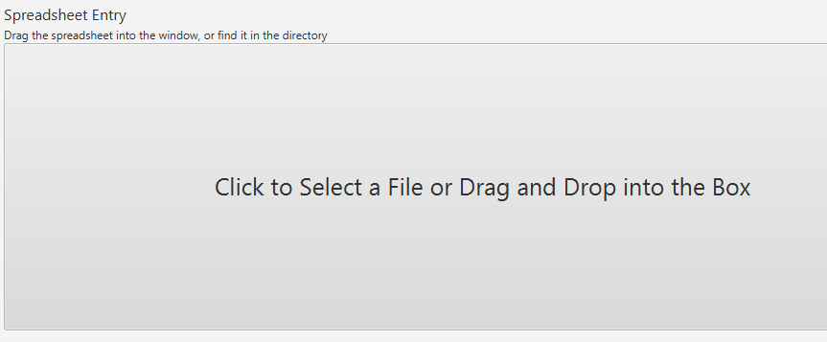

The Spreadsheet Data Entry Box is for inputting data into the application by giving the application an excel spreadsheet.

There is one big button in the box. Clicking on the button will open a dialog box with the file directory of the computer. In the dialog box, select an excel spreadsheet and the application will input the different information in the spreadsheet into the application. Alternatively, you can drag the excel spreadsheet into the button and it will do the same thing.

There are some specifications as to how the spreadsheet should be formatted.

In order for this to work properly, the first row of the spreadsheet needs to be reserved for the titles of the different values of each student and each row represents a different student.

In the first row, there needs to be All of the Following:

* A cell that has “id” in it to denote the student id.
* A cell that has “first” in it to denote the first name. There can’t be numbers in the cells under it.
* A cell that has “last in it to denote the last name. There can’t be numbers in the cells under it.
* A cell that has “school” in it to denote the middle school
* One of the Following (the first option is preferred over the second option):
  + A Cell that has “house” in it to denote the houses a student is visiting. In all cells afterwards, “glo” denotes a student is visiting global, “hum” denotes a student is visiting humanities, and “smcs”, “math”, or “sci” denotes a student is visiting smcs. All of these can appear in the same student house column.
  + All of the Following
    - A cell that has “smcs”, “math”, or “sci” in it to denote whether a student is visiting smcs
    - A cell that has “glo” in it to denote whether a student is visiting global
    - A cell that has “hum” in it to denote whether a student is visiting humanities
    - In the student cells under each of these columns, one of the following formats needs to be followed
      * the cells can have a “y” or “true” or to denote that a student is visiting a respective house
      * the cells can have the number 1 to denote that a student is visiting a respective house.

The terms in quotes above are not case sensitive.

Additionally, if you are using a spreadsheet generated by the google form made for the program, it should be fine.

If the data is successfully inputted into the application, the spreadsheet data entry box will be replaced by a new box that says “The Data was successfully entered into the System.”

If the data wasn’t successfully inputted into the application, the spreadsheet data entry box will remain present, or a new box will appear that says the data wasn’t entered into the application, please try again.

# Rotation Information

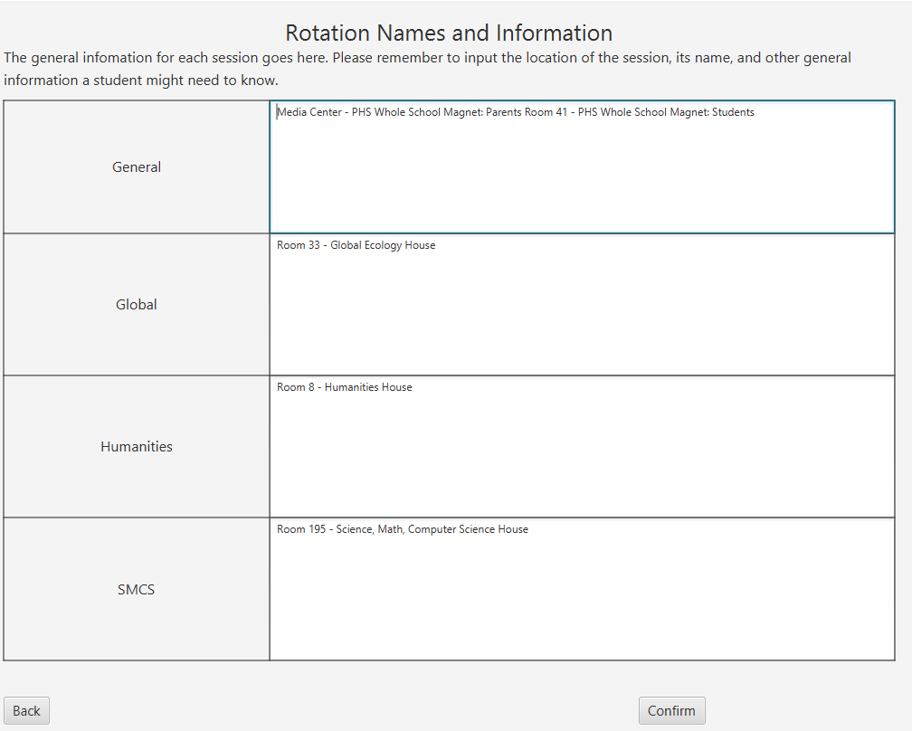

The Rotation Information window is where you set the descriptions for each rotation on each student schedule.

In each Text Area, be sure to type in the location of each rotation, as well as some indication as to what magnet house it is for.

Clicking the Confirm button will save edits into the database of the application and set the text you have written down as what is to be replaced in the student schedules for each rotation.

**Back** - Leads back to the Start Menu

# Schedule Manager

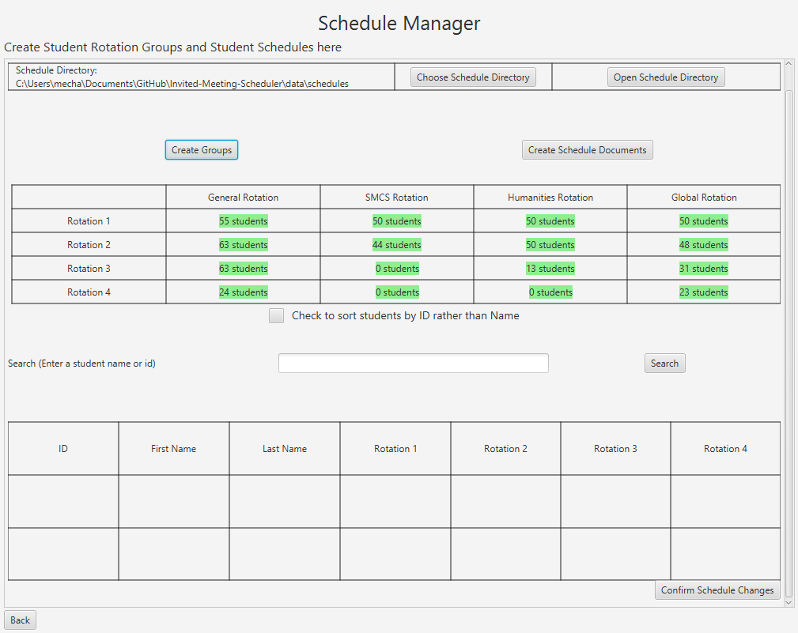

The Schedule Manager is where changes to the student rotations and schedules take place.



In the top row is the controls for setting the location/directory where the student schedules are created and stored in.

* The First cell tells you the path to the directory.
* The Second cell has a button, which clicked will open a window for you to choose the Schedule Directory.
* The Third cell has a button, which clicked will open the Schedule Directory in the file explorer.

The Next Row has 2 buttons:



* **Create Groups**: clicking this will create a grouping of students for the Open House. The result of the groups will be shown in the Table below.  
  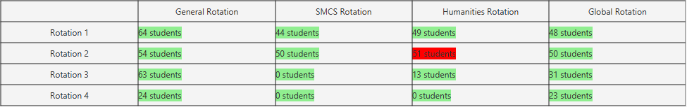  
  In the Table, if a value is in green, it means the specified session has a value between 10 and 50 for House sessions, a value between 10 and 70 for General sessions, or a value of 0.  
  If a value is red, it means there is either a value greater than 50 for House sessions, a value greater than 70 for General sessions, or a value between 1 and 9. Under these cases, it is deemed that the specified session has a not ideal amount of students in it, but the program doesn’t know how to create a result where this isn’t the case.
  + Clicking on one of the colored boxes will open up the list of students participating in the selected session. It will show the students id, name, school, and other rotations.
    - By Default, the list is sorted by last name, but can be sorted by id by checking the box below the table.  
      
* Please note that by clicking the **Create Groups Button**, any edits made to the schedule afterwards will be overwritten. Additionally, groups won’t be saved after the application is closed.
* **Create Schedule Documents**: clicking this will create the individual schedules for each student in the specified Schedule Directory.
  + The Program will warn you if there are any unideal groupings.

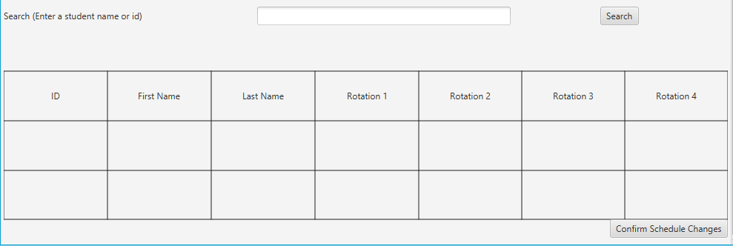

This area is to search for specific students and edit their schedules.

The searching for the students is done through the text field, where a students id can be entered or a students name can be entered.

In the box, either type in the 6 digit integer of a specific student (ex. 123456) or type in the student’s name (ex. Thomas, Jones, Thomas Jones, Jones Thomas).

* For the student’s name, it can be just the first name, just the last name, or both of the names in any order.

If a match was found, the bottom table will add in the something like the following:

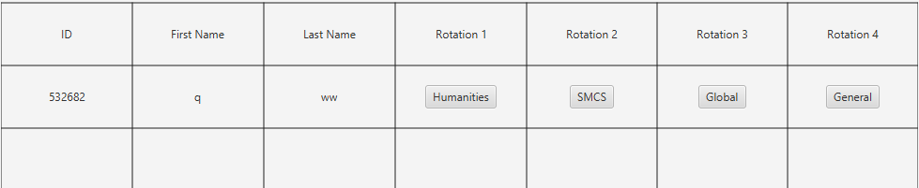

The students data is shown, their ID, name, and their rotation schedule.

Additionally, their rotations are shown using buttons. Clicking any one of the buttons will move that button to the bottom row, for example:

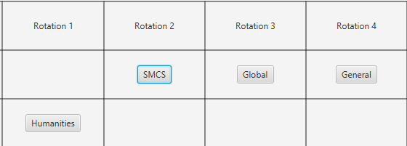

Clicking the Button again will move the button back up.

Clicking one of the other buttons will switch the two buttons, for example:

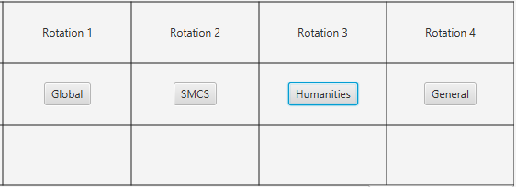

In this example, humanities was switched with global.

In order to confirm a schedule change, click on the **Confirm Schedule Changes** Button, and the value will be stored in the application database.

# Information Sheet

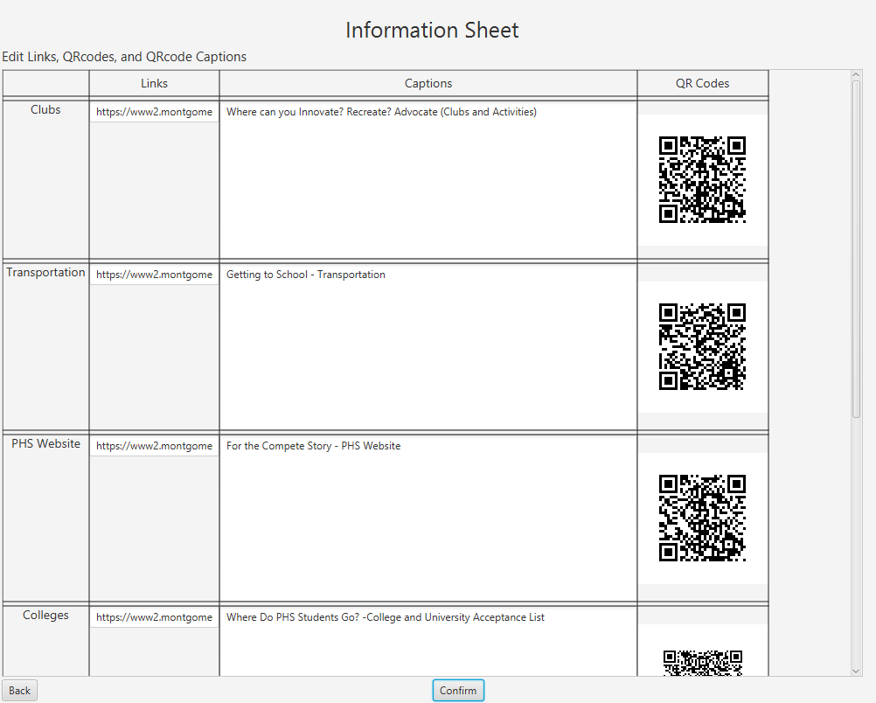

This is where Links, Captions, and QR Codes are edited in the application and transferred to the schedules.

In the Links column is where all the text fields relating to the links for the qr codes of each category are edited and changed. This gives the information needed to create the qr codes.

In the Captions column is where all the text areas relating to the captions for the qr codes of each category are edited and changed. This gives the information informing the students about the qr codes and where they lead.

**Confirm** - Clicking on this button will store the links and captions into the application, as well as update the QR codes with the new links.

**Back** - Leads back to the Start Menu

# Map

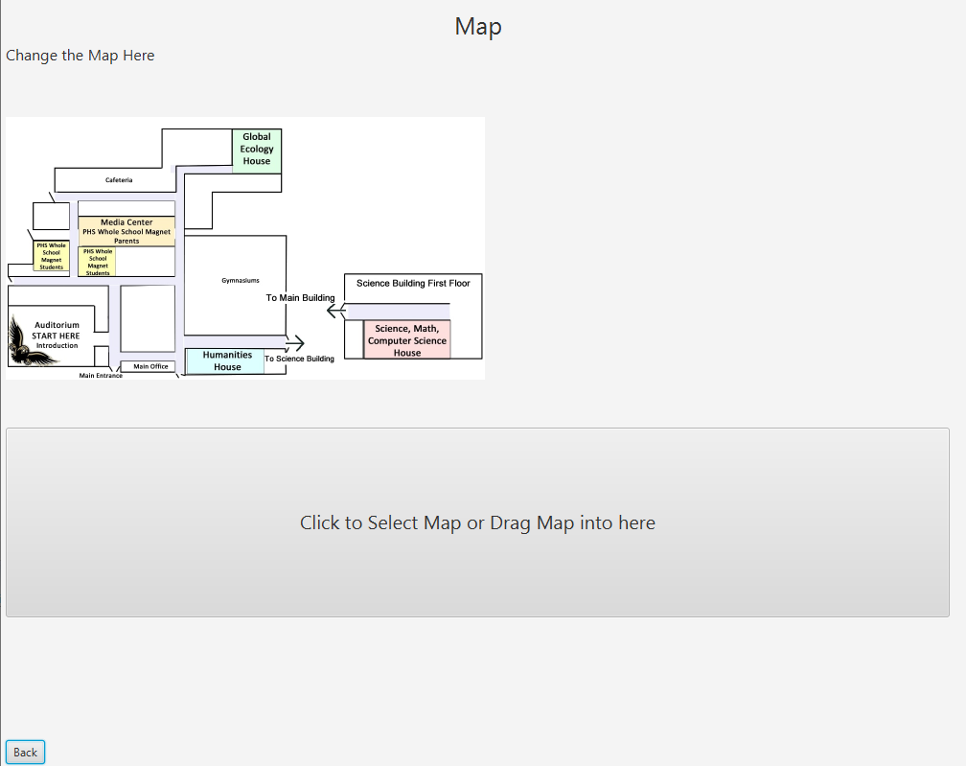

This is where changes to the map occurs.

Clicking on the big button in the middle will bring up a dialog box where you can select a file for the map image. Alternatively, an image file could be dragged into the box and the same thing will be accomplished. Completing any one of these actions will result in the map image being replaced in the system.

**Back** - Leads back to the Start Menu